CCI Western India Slam, Mumbai
04-09 December 2023
Under aegis of Maharashtra Squash Racket Association and Squash Rackets Federation Of India
ASF Gold event, 5 Star National Circuit Tournament
Important Info | Player Guidelines - http://indiasquash.com/pdf/Player%20Guide%20-Ver%201.0.pdf
Important Info | Championship Guidelines - http://www.indiasquash.com/pdf/Ranking%20Guidelines%202018.pdf
Registration Open Date – 01st OCT 2023  Registration Closing Date – 31st OCT 2023 |  | Juniors – 5 star | Seniors – 3 star |  |  | Masters – 3 star
Local players entry fee - INR 700  Foreign players entry fee – INR 2500 |  | Prize money - No Prize money for Juniors. Senior prize money $1k each category |  | Play offs - Top 8 for Juniors  Format – Knockout
Seeding based on – OCT 2023 |  | Draw Type – Main Draw
Events - Boys and Girls - 11, 13, 15, 17 and U19
PSA Satellite ($1K Men and $1k Women)
Masters’ Over 35, 45, 55
Championship Venue – Brabourne Stadium, Sir Dinshaw Vachha Road, Mumbai - 400020
Court Type  6 Squash Courts |  | Air-conditioned – Yes (2 Courts) |  |  | Tin Height – 19 inches
Organising Chairman - Mr. Mr. Janak Madhavdas |  | Phone - +91 9821098845 |  |  | Email ID –janak.madhavdas@gmail.com
Championship Director – Mr. Bobby Bajaj |  | Phone - +91 9821098845 |  |  | Email ID –  bobbysbajaj@gmail.com
Championship Administrator – Mr. Rohit More |  | Phone - +91 9820822164 |  |  | Email ID –  rohitsquash@gmail.com
Federation Contact | National Circuit Chairman - Cyrus Poncha | cponcha@gmail.com | Grievance - office@indiasquash.com
Functions | Prize Distribution ceremony will be on 09th December. It is mandatory for all medal winners to be present at the prize distribution ceremony. Awards will not be given to any other person.
Prize money deductions | TBC
Disclaimer | The SRFI will not be responsible or liability for the welfare or safety of players / officials during the Championship, Whilst the organising body will take all reasonable steps to advise players / officials on this matter, it remains the responsibility of players to confirm their own appropriate insurance cover and for the organiser of the event to ensure full and adequate safety, security and insurance measures being in place for players / officials.
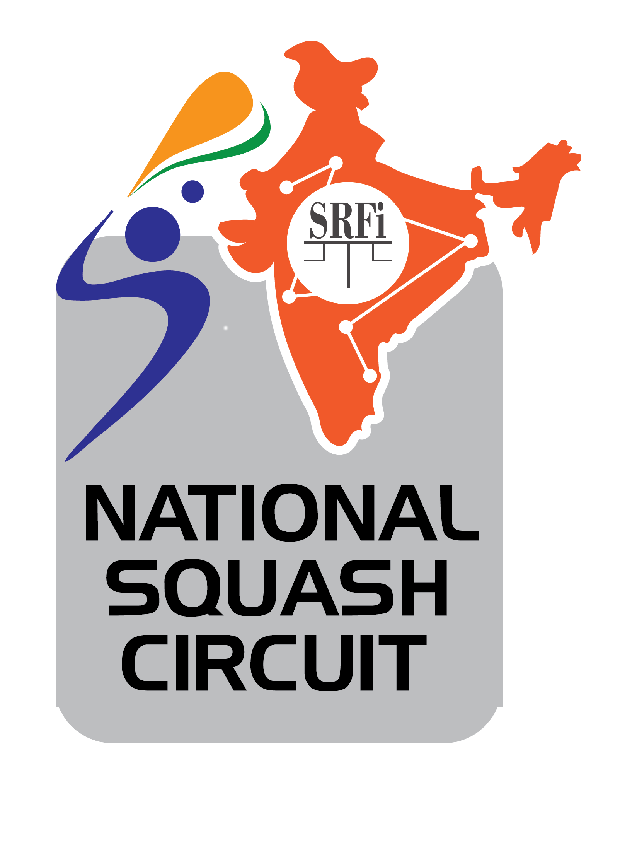


Championship Hotels
Residency Hotel Fort, Mumbai (300 metre from the Venue)
Corner of, 26, Rustom Sidhwa Marg, Dr Dadabhai Naoroji Rd, Opp Citibank, Fort, Mumbai, Maharashtra 400001
Phone: 022 6667 0555 , Email – reservations@residencyhotel.com

Sea Green South Hotel (1.5 km from the Venue)
145, Marine Drive, Next to Pizza by the Bay Mumbai
Phone: +919833913350 , Email – mail@seagreensouth.com

Hotel Chateau Windsor (1.1 km from the Venue)
86, Veer Nariman Road, Churchgate, Mumbai – 400020
Phone: 02222044455 , Email – info@cwh.in
Contact Person – Mr. Joy (9869381113)

West End Hotel (1km from the Venue)
45, Marine Lines, Next to Bombay Hospital, Mumbai - 400020
Phone: +919372428880 &+912240839121 , Email – westendhotelmumbai@gmail.com
Contact Person – Rahul Dolas
Ambassador Hotel (1.4 km from the Venue)
V.N.Road, Churchgate
Phone: +917045787180 , Email – sales1.mum@ambassadorindia.com
Contact Person – Varsha Sakhale

